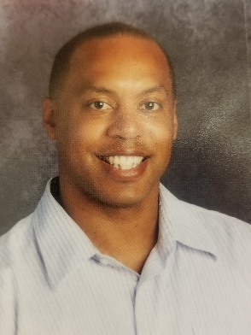

Ronnie Beard
Position: Teacher
Local Association: FCTA

Hello MSEA Family! It would be my honor again to represent you all at the NEA RA this coming year! I wish to be your voice and bring your issues and concerns to the national level! Thank you again for your vote of confidence to represent you! Vote Ronnie Beard

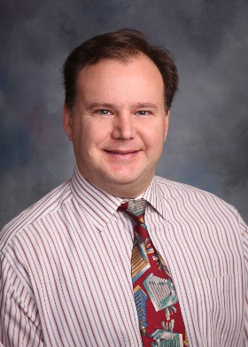

Neil Becker
Position: Teacher
Local Association: WCTA(Washington)

In WCTA, I currently serve as the president, after serving as treasurer and vice president. Over the years, I have been elected by my local and by MSEA members to be an MSEA delegate.
I hope to continue representing MSEA at the NEA RA and being a voice for all educators.

Joshua Davidson
Position: Teacher
Local Association: CCEA(Carroll)

I feel it is an honor and a privilege to represent MSEA at the NEA Convention. As Co-Chair of IPD, I utilize my time at the NEA Convention to not only vote on important NBIs, but to also collaborate with colleagues across the nation concerning professional development issues. Please vote Josh Davidson for delegate!

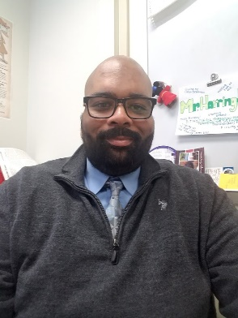

Jesse Harrington
Position: Teacher
Local Association: CCEA(Carroll)

Our goal as teachers is to provide quality education to students and our associations hold the key to equity. I have attended PDS provided by MSEA that has increased my knowledge of equity strategies. The NEA convention will provide our associations with tools to fight and it would be an honor to be a delegate.

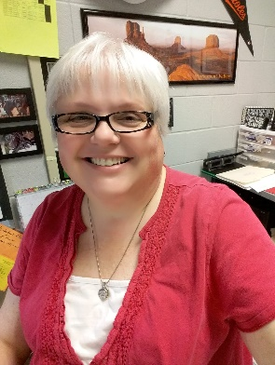

Celeste Jordan
Position: Teacher
Local Association: CCEA(Carroll)

Every union event I attend, I learn something. I had no idea when I became more active in CCEA that I would grow so much professionally. I am a better educator and a better leader. I strive to bring what I learn back to my local to further our organization.

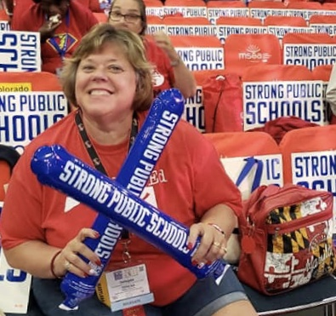

Teresa McCulloh
Position: Teacher
Local Association: CCEA(Carroll)

There is no better way to get firsthand experience than to participate in the NEA Representative Assembly as a delegate. Members want to know the topics/issues of our national affiliate that affect our jobs, schools and students. I will be that CCEA voice when you make it possible for me to attend. Thank you!

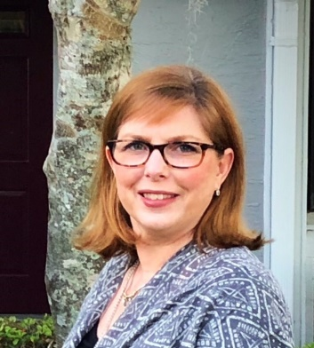

Kelley McDonough
Position: Teacher
Local Association: CCEA(Carroll)

According to NEA President Lily Eskelsen García “Political action isn’t subversive. It’s the essence of democracy. Showing up informed and engaged, prepared to make a difference is exactly what democracy looks like.” Representing my colleagues around Maryland at NEA is my greatest honor. Let me make a difference for you!

Kimberly Sloane
Position: Teacher
Local Association: ACEA

It is a privilege and honor to be chosen to represent our nearly 74,000 MSEA members at the largest labor union gathering in the United States: the NEA Representative Assembly. In doing so, I will diligently participate in every aspect of the democratic process and be a voice for our students and educators across Maryland.

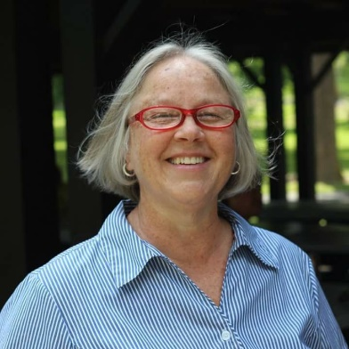

Robin Spickler
Position: Teacher
Local Association: WCTA(Washington)

Experience is a must….along with knowledge to help guide and support all educators. I have the experience and knowledge plus the desire, passion and commitment! Every educator deserves to have someone in their corner 100% ~ I am that person.

Robin Szymanski
Position: Teacher
Local Association: CCEA(Carroll)

As a Carroll County Special Educator, I am an advocate for Students, Educators and Appropriate Change who appreciates and supports students and educators, and will use my voice to pave a path for ALL students to be honored and accepted, and educators to be appreciated as professionals.

