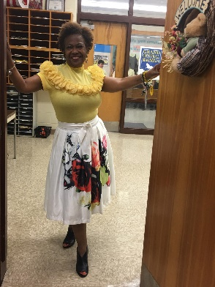

Demetrice Bettis
Position: Teacher
Local Association: PGCEA

Vote for me, Demetrice Bettis: Active Leader; FAC, Chair; 2019 Delegate; ECE; MC-MSEA; Sponsor/Coach - Science Bowl; Sponsor/Coach - Robotics

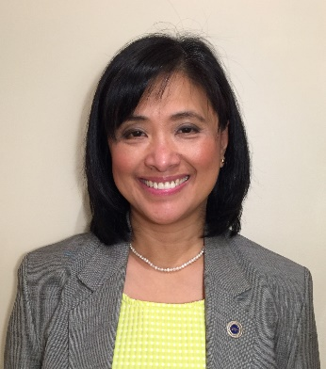

Rose Mary Bunag
Position: Teacher
Local Association: PGCEA

My name is Rose Mary Bunag and last year was my first time at the NEA Representative Assembly. My attendance helped me as a National Board Certified Educator and Consulting Teacher to support teacher capacity. I got involved, shared important information, advocated for educators, and contributed to student success. I look forward to another year.

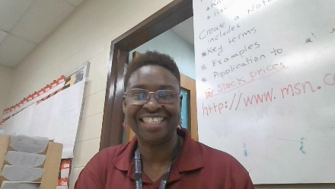
Claudette Clarke
Position: Teacher
Local Association: PGCEA

I am an active National Board Certified teacher who mentors other teachers. A Building Representative for several years and one who can organize & galvanize members for ACTION! I am also an Active MSEA Delegate who takes that responsibility very seriously! Vote for me to get things done.

Raoul Daggett
Position: Teacher
Local Association: PGCEA

I am a thirty plus member of PGCEA and MSEA and have been afflicted with both for over the thirty years. I have been a building representative, MSEA advisory and NECC for PGCEA. It has been sheer pleasure to serve in all capicities.

Deidra Daniels
Position: Teacher
Local Association: PGCEA

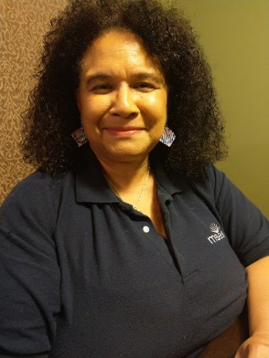

Devorah Danielson
Position: Teacher
Local Association: PGCEA

Proud and Active NEA/MSEA member! Dedicated to Uplifting Public Education, Progressive voting on educational issues - Delegate at state and national levels, National Board Certified Teacher-CTE, NEA Group Facilitator Working with educators at the National Level, Forward Thinking-Activist-PAC Donor-Volunteer, Will Speak, Show and Step Up! Belief in Power of Educators as Esteemed Professionals Deserving Autonomy

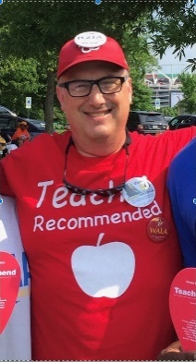

Thomas Duke
Position: Teacher
Local Association: PGCEA

When teachers are organized and energized, we win. Organized teachers will bring public funds into our classrooms. Teachers work with students every day. The public funding teachers are fighting for must go into those classrooms for our students. Teachers give our students the best education. Now is time to fund for the best future.

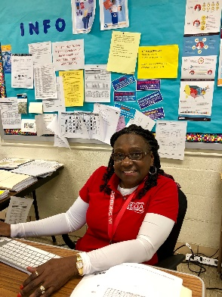

Ayana English-Brown
Position: Teacher
Local Association: PGCEA

I have been a member of NEA and MSEA for 22 years and a delegate for over 10 years. I have worked hard representing educators in my association. As a business teacher, national board teacher, union representative, local and state member of the Minority Affairs Committees, I will continue to fight for educators' rights.

Sharon Flynn
Position: Teacher
Local Association: PGCEA

I am an experienced MSEA and NEA Delegate. I serve as the Secretary and Mid Atlantic Regional Director of the NEA ELL Caucus. I am a member of the NEA Maryland Delegation Resolutions Committee. At home I am an active member of the MSEA and PGCEA GO Teams and of the PGCEA Government Relations Committee.

Brian Glover
Position: Teacher
Local Association: PGCEA

Please vote for Brian Glover. I have been teaching for 20 years and would love to be a delegate. I am active in our State and local Union. I am willing to serve and give my very best in representing our educators. I was a first time delegate to Ocean City in Maryland. Thanks

Anthony Hart
Position: Teacher
Local Association: PGCEA

As an Educational Leader, I have demonstrated a deep commitment to public education and advocacy. I remain passionate about ensuring that your concerns and our voices are heard. I have demonstrated the leadership ability to improve working conditions and employee morale. We are Great Public Schools, because of your passion, purpose, and perseverance.

Sherida Hickman
Position: Teacher
Local Association: PGCEA

I think that it is very important to be a Delegate to the convention to gain knowledge about what is going on in the Educational community and how I can be an effective advocate for our students. Being a part of this organization is very important to me.

Felixberto Lazaro
Position: Teacher
Local Association: PGCEA

I want to represent my local association and the members to the NEA and MSEA Representative Assemblies so that they can be heard as one voice. The venue is an effective platform for presenting new business items for the welfare of our students, families and teachers. I will meet delegates from other places.

Averill Malone
Position: Teacher
Local Association: PGCEA

There is something for everyone if only they try their best. These ethos inspires me to inspire students everyday.

Kristi Maslak
Position: Teacher
Local Association: PGCEA

Stephanie Massey
Position: Teacher
Local Association: PGCEA

I enjoy bringing new, innovative ideas to various committees, addressing the issues that affect educators and students using diplomacy, but ready to stand up making my voice heard when needed. I love teaching and mentoring our students and teachers inside and outside of the classroom, empowering and inspiring them to stand up for their rights.

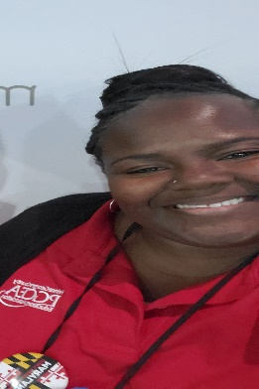

Melanie Mavins
Position: Teacher
Local Association: PGCEA

My vision is to help and assist with the movement of uniting teachers for quality service, socio-economic improvement, professional advancement, and strengthen their bargaining power and promote quality education through effective leadership and effective programming.

Robin McNair
Position: Teacher
Local Association: PGCEA

As an advocate for racial and social justice in our schools, I desire to serve as delegate to the 2020 NEA Representative Assembly to ensure students have a voice and vote on equity and inclusion in the classroom, in our policies, and in our communities. A vote for me is a vote for Educational Equity!

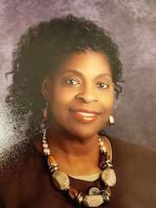

Veronica Monroe
Position: Teacher
Local Association: PGCEA

Please allow me to serve as a delegate for the 2020 MSEA/NEA Representative Assembly. I have served in the following capacities: Legislative Committee (MD - state level), Faculty Advisor Chair (local level - PGCEA), Building Rep (local level - HCEA/MCEA), Minority Affairs Committee (PA - state level), and Collective Bargaining Committee (PA - state level).

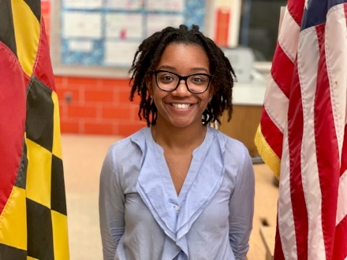

Kayla Moore
Position: Teacher
Local Association: PGCEA

Teaching and advocating for students and teachers is my passion. I served as president for the MSEA chapter at Coppin State University, spoke at Fix the Fund Rally in Annapolis, and lobbied to state delegates in order to push the Kirwan Commission. I would love to continue my advocacy as a MSEA and NEA delegate.

Mark Naydan
Position: Teacher
Local Association: PGCEA

I have been a union representative in my school for 15 years and support teachers not being overburdened with large class sizes, extra work that does not benefit children and unreasonable testing requirements. I sponsored a legislative amendment last year to make class size limits a legal option when collective bargaining. It was passed overwhelmingly.

Vera Ngwa
Position: Teacher
Local Association: PGCEA

Teresa Oliver
Position: Teacher
Local Association: PGCEA

I am continuing to learn more at each convention and I would like to continue this great process in the union.

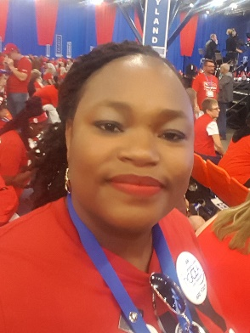

Philimena Owona
Position: Teacher
Local Association: PGCEA

VOTE, Philimena Owona! Public education is under attack! Join me, speak for equity and access in public education - a work of conscience. Vote Philimena Owona, for MSEA Delegate-at-Large, a 20-year educator; passionate, dedicated advocate for strong public education. Building Rep/FAC Chair, PGCEA delegate to MSEA, SPARKS Co-Chair, Minority Affairs Committee, MSEA GO-Team.

Verda Peterkin
Position: Teacher
Local Association: PGCEA

Cassandra Peters-Johnson
Position: Teacher
Local Association: PGCEA

I was humbled and delighted to represent MSEA at the NEA Convention in Houston. I look forward to serving again as a delegate in my hometown Atlanta. The NEA Convention and Representative Assembly is the place to be in July. It is where educators make things happen. I serve on MSEA committees while at NEA.

Stephanny Powell
Position: Teacher
Local Association: PGCEA

I started as an active WTF Union Member in Washington, DC back in SY 1997-1998. I've been a member in PGCEA for the last 12 years. I have stepped up, showed up, marched, stood up, lobbied, advocated and testified to make my voice be heard for a better educational system for our educators and children.

Marilyn Quow
Position: Teacher
Local Association: PGCEA

As a MSEA/NEA and PGCEA member it is my passion to fight for teachers and students right as I have been doing and being a delegate will give me the training and a platform to continue to fight and to help make this association stronger. I have been to many marches in Annapolis

Delisa Robinson
Position: Teacher
Local Association: PGCEA

I have been a member of PGCEA for 15 years. I am interested in exacting education reform by rebranding and elevating the teaching profession, ensuring that teacher "voice" is heard in any and all education policy. I would appreciate your vote to be a delegate at the NEA Representative Assembly.

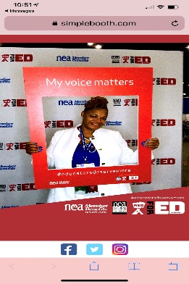

Nicola Ross
Position: Teacher
Local Association: PGCEA

Would you like an 17-yr. Special Educator with experience to be your Delegate? I’m the one-I’m on the NECC for PGCEA as well as: Special Education, ByLaws and Greviance Committee with PGCEA. 2019-NEA-RA Elections member. My goals are to stay Connected for students. Vote for me, Nicola ROSS!

Keesha Singletary
Position: ESP
Local Association: ACE-AFSCME, Local 2250

I am a devoted educator and would love to have the opportunity to be a participant in the NEA's Representative Assembly. Please vote for me.

Malvery Smith
Position: Teacher
Local Association: PGCEA

I am a Union Supporter. Too many times the Education field is pushed aside and we must fight for our students so that they will match up with other districts around the USA. I intend to be in that fight and do whatever it takes to help them.

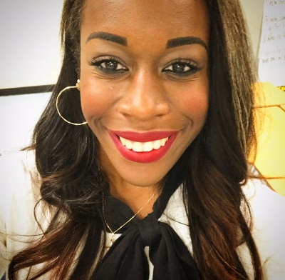

Ariel Stone
Position: Teacher
Local Association: PGCEA

I am the daughter of education. My whole life has consisted of witnessing/experiencing inequities in education that have positive correlation with the nature of the woe's of today's American society. I view being a member of the MSEA and NEA representative assemblies as my conduit to actively fighting these inequities. I do not take membership lightly.

Victor Tarkeh
Position: Teacher
Local Association: PGCEA

I am proud of almost 3 decades of vested teacher advocacy in four different countries with varied conditions, but very similar issues across the board. Overall, I always say that there will be no great teachers and great union without great students.

Leslie Tejano
Position: Teacher
Local Association: PGCEA

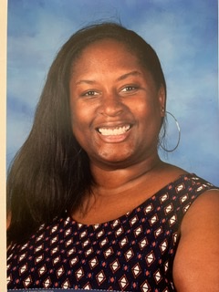

Ryan Walker
Position: Teacher
Local Association: PGCEA

I would like to represent PGCEA and MSEA at this critical time in education as a delegate to the national convention. This delegation will be imperative in moving education forward.

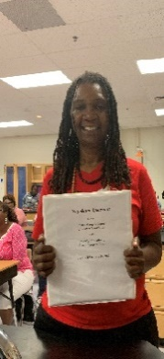

Zena Whitworth
Position: Teacher
Local Association: PGCEA

In order to make a difference in education, I decided to do my part by learning all levels to a process or a system in order to impact or facilitate real change in an evolving society. As a state delegate, I will perform my duties in accordance with what is good for the entire state.

Lawrence Williams
Position: Teacher
Local Association: PGCEA

Alicia Yap
Position: Teacher
Local Association: PGCEA

I am currently working as a reading specialist in an elementary school. I want to become a delegate again for the NEA convention because I want to be part of a big organization that aims to positively impact the education field for the benefit of the members of a professional learning community.

